Switch-port security and Troubleshoot

1. **Requirement**

|  |  |  |  |
| --- | --- | --- | --- |
| Device | interface | IP | Subnet mask |
| Sw0 | VLAN 1 |  | 255.255.255.0 |
| Pc1 | Fa 0/1 | 10.10.10.11 | 255.255.255.0 |
| Pc2 | Fa 0/2 | 10.10.10.12 | 255.255.255.0 |

1. **Task**
2. Configuring switch-port security on layer 2 switch
3. Verifying the port security
4. Troubleshooting after violation.
5. **Diagram**

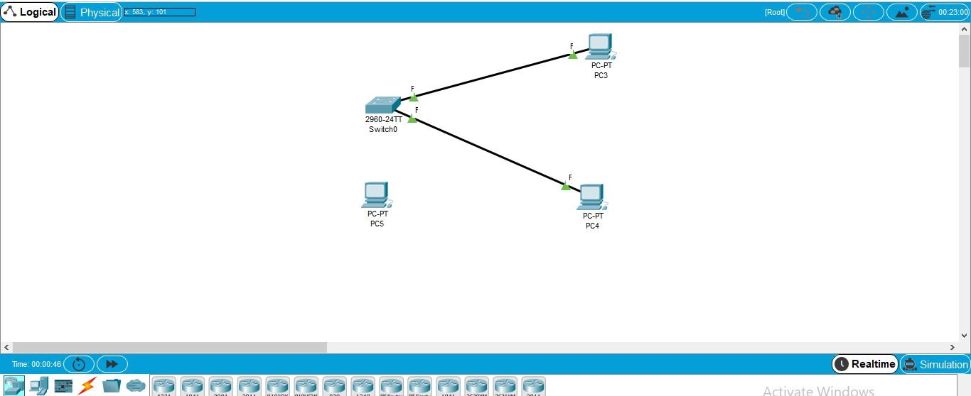

Task 1:

1. Enabling port security for fa 0/1 and fa 0/2
2. I Put restrict command on fa 0/1 and protect command on fa 0/2.
3. Disabled other ports by shut down command.
4. **Verification**
5. Ping **pc1** to **pc2**.
6. Check if the devices got their mac addresses. **(go to pc >cmdpromt> pc> ipconfig /all)**
7. Attach the rogue pc to any disabled port and verify the link ports **are red.**
8. Now enable that port and ping.
9. Disconnect the **pc2** and connect **with rogue pc**. And check if its able to ping pc1. (it will not ping)
10. The port to which the rogue pc is connected, show its port violation (**command: show port-security violation)**
11. **Troubleshoot**

After the violation, to get the port to its normal mode; do the following command.

**Sw0(config)# int fa 0/2**

**…………………#sh**

**…………………#no sh**